**GOVERNMENT DEGREE COLLEGE NARASANNAPETA**

**DEPARTMENT OF ENGLISH**

**DEPARTMENTAL TIME TABLES 2017 – 2018**

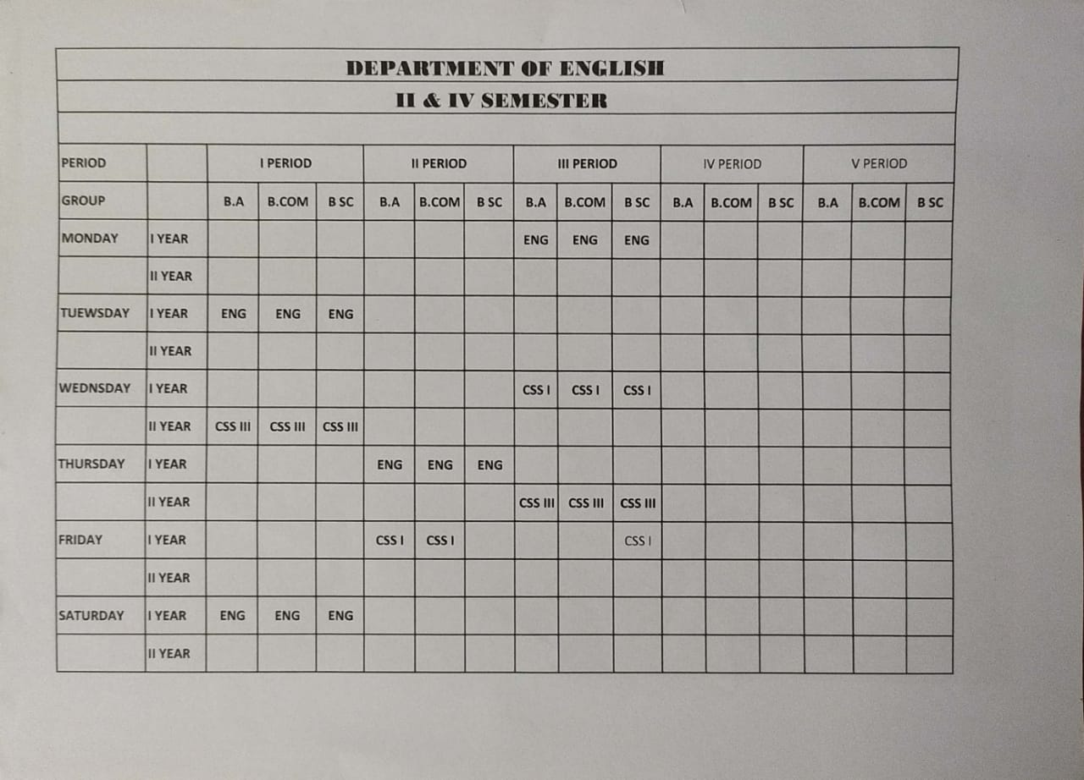

**GOVERNMENT DEGREE COLLEGE NARASANNAPETA**

**DEPARTMENT OF ENGLISH**

**DEPARTMENTAL TIME TABLES 2018 – 2019**

